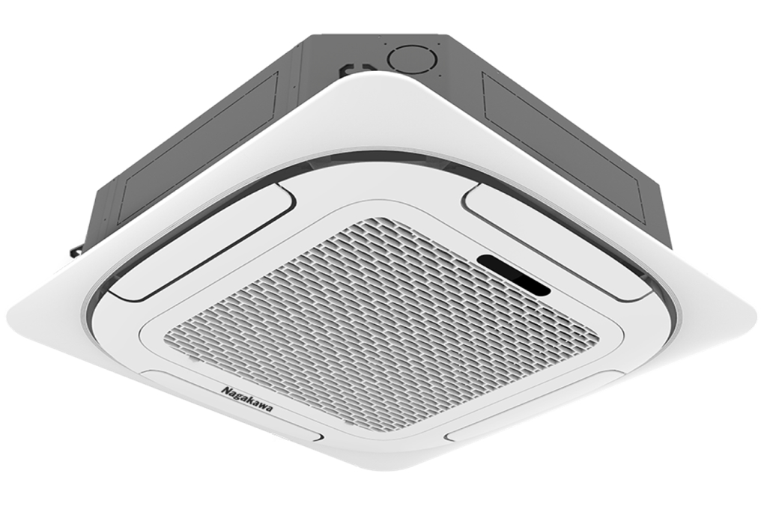

**27,400,000 VND**

**Technical specifications of Nagakawa 3 HP ceiling air conditioner NT-C28R1T20**

* Machine Type:

1 way (cooling only) No Inverter

* Cooling capacity:

3 HP - 28,000 BTU

* Effective cooling range:

From 40 - 50m² (from 120 - 150m³)

* Dust filter, antibacterial, deodorant:

Dust filter mesh

* Power saving technology:

Eco

* Rapid cooling:

Super

* Utilities:

LED display screen

* Cooler:

Length 84 cm - Height 84 cm - Thickness 24.5 cm - Weight 25 kg

* Outdoor:

Length 70 cm - Height 84.5 cm - Thickness 33 cm - Weight 43 kg

Introducing the company 

- Vietnamese brand.  
- Established in 2002.  
- Diverse business products: air conditioners, dishwashers, induction cookers,.... with product prices easily accessible to consumers.  
- Achieved many outstanding achievements: Top 100 best products for families and children (2023), golden brand for Vietnamese health (2019),...

***Nagakawa 3 HP NT-C28R1T20 ceiling air conditioner has Super fast cooling mode, cools the space quickly. In addition, the air conditioner also has Eco technology to save electricity, 360-degree airflow to help cool air spread evenly to every corner, dust filter to remove coarse dust, dirt,...***

**Design**

**Cooler:**

**- Nagakawa 3 HP NT-C28R1T20 ceiling mounted air conditioner**  has a square design with **a thickness of 24.5 cm,** suitable for factory, office, and restaurant projects.

- The LED display screen on  [the air conditioner](https://www.dienmayxanh.com/may-lanh)  clearly shows the temperature, users can monitor it easily without looking at the remote.

**Outdoor:**

- [Nagakawa air conditioner has a](https://www.dienmayxanh.com/may-lanh-nagakawa)**horizontal rectangular**  design   with a sturdy shell, anti-rust and resistant to external weather conditions, durable over time.

- Use **Hydrophilic-coated aluminum** heatsinks  with  **pure copper gas pipes**  for fast heat transfer and long-term use.

**Refrigeration technology**

- Nagakawa NT-C28R1T20 is designed  **with a capacity of 3 HP** , effective cooling range **from 40 - 50m² (from 120 - 150m³).**

-  **Super fast cooling technology** : enhances performance as soon as this mode is activated, instantly cooling the space, helping you enjoy a refreshing feeling.

**Air blowing mechanism**

[The 3 HP air conditioner](https://www.dienmayxanh.com/may-lanh?g=tren-25-hp)  is integrated with **360-degree automatic air flaps** , air is sent to everywhere in your room, cools quickly, creating a comfortable feeling.

**Power saving technology**

**Eco technology** : this [Nagakawa ceiling air conditioner](https://www.dienmayxanh.com/may-lanh-nagakawa-am-tran)  automatically increases **2⁰C** above the set temperature because the compressor operates at low efficiency, saving maximum electricity. From there you will save a significant amount of monthly electricity costs.

**Air filtration ability - health**

**The dust filter** removes fine dust, coarse dust and tiny particles, providing fresh air. In addition, the mesh can be easily removed and cleaned, so you can proactively clean it after long periods of use. The system operates smoothly, **noise level is only 41 dB** , does not cause noise pollution, bringing comfort to the whole family.

*In general,*[*the Nagakawa 3 HP NT-C28R1T20 ceiling air conditioner*](https://www.dienmayxanh.com/may-lanh/am-tran-nagakawa-3-hp-nt-c28r1t20)*has an effective cooling range of 40 - 50m² (from 120 - 150m³) and is suitable for use in factories, conference rooms, offices, libraries,... Thanks to the Super fast cooling technology, power-saving Eco mode and 360-degree air swing mode.*